Multimodal Experience Outstanding Project of the Year Award
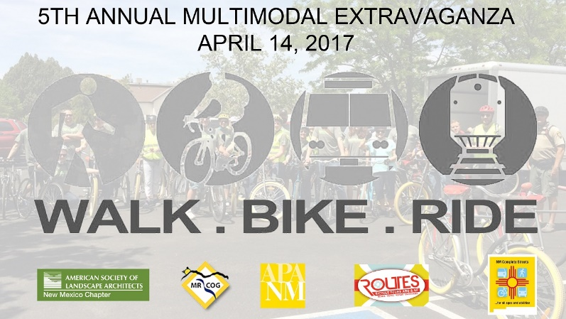
This year, as a part of the Multimodal Experience, we would like to honor an outstanding project or effort from the past year (calendar year 2016) that supports and advances multimodal travel in the state of New Mexico. Various types of projects and efforts will be considered: studies, plans, research efforts, projects in the planning, design, construction, or evaluation phase, programs, campaigns or any other effort or event that relates to multimodal travel. Submissions may be affiliated with professional organizations, university or academic departments, nonprofits, advocacy groups, government agencies or departments, and the private sector. Projects do not need to have been completed in 2016, only underway. Applicants can be nominated by another person or group or may be self-nominated. Applications will be reviewed and judged by a Multimodal Experience planning panel. Applications are due on April 7th. Please fill out all eight fields below (note: if you are nominating a project you did not work on/are not affiliated with, you do not have to include visuals (#7)). Please send nominations to Tara Cok at tcok@mrcog-nm.gov.
- Project Title:

- Lead Agency/Organization/Author(s):
- Project Completion Date or Expected Completion Date:
- Project Description (200 words or less):

- How does this project benefit multimodal options and/or conditions for the community?

- How has this project exceeded the status quo in terms of quality, approach, or other?

- Please include up to five visuals of the project (renderings, photographs, graphs, charts, tables, etc.)

- Why does this project deserve consideration as the Multimodal Experience Outstanding Project of the Year?

